FREP Sampling Design Report
Title: FREP Sampling Design: Recommendations for Improved Implementation
Authors: Darcy Pickard, Alex W. Hall, and Ruth Joy
Acknowledgments:
The authors would like to thank the following people, who all contributed to the development of the present work:
- The FREP team, including Peter Bradford, Nancy Densmore, Frank Barber, Richard Thompson, and Wendy Bergerud for their input and guidance throughout the project;
- The many anonymous participants in the initial survey on FREP user needs for their feedback;
- The participants in the subsequent workshop, including Frank Barber, Paul Barolet, Dan Bate, Greg Belyea, Wendy Bergerud, Peter Bradford, Bill Chapman, Nancy Densmore, Jessie Fanucchi, Jon Flintoft, Kerri Howse, Elizabeth Hunt, Zaid Jumean, Lyn Konowalyk, Dave Maloney, Teresa Newsome, Kathy Paige, Carl Pollard, Martin Ponsioen, Lucy Stad, Richard Thompson, Derek Tripp, Eric Valdal, Warren Warttig, Craig Wickland, and Ken Zielke, for their insights and engaged discussions

Table of Contents
A. INTRODUCTION 3
A.1 Context 3
A.2 Previous Work 3
A.3 Guiding Principles 3
B. RECOMMENDED APPROACH 5
Component I: Getting more benefit from the existing data 7
B.1 Further Use and/or Exploration of the Existing Data 7
B.2 Information at Low Sample Sizes 11
Component II: Allocation of annual samples to core FREP design 18
B.3 Summary of Approach 18
B.4 Rationale 18
B.4.1 Rationale for overall approach 18
B.4.2 Rationale for specific elements of design 20
B.5 Implementation 23
Component III: Allocation of annual samples for district-level priorities 25
B.6 Summary of Approach 25
B.7 Rationale 25
B.8 General Guidance on Implementation of Priority Sampling 25
B.8.1 Obtaining context-specific statistical advice 27
C. OTHER DESIGN OPTIONS CONSIDERED 29

APPENDICES 35
Appendix 1: The FREP Sampling Design 35
Appendix 2: Other Large-scale, Multi-value Monitoring Programs 36
Appendix 3: Examples of the Allocation of Annual Samples 38
Districts with high versus low recent sampling 40
Alternate allocations of sampling effort for a single district 41
Example of reactive planning for the allocation of samples 44

INTRODUCTION

Context
The Forest and Range Evaluation Program (FREP) provides the resource stewardship monitoring component of the Forest and Range Practices Act’s (FRPA) legislative framework. FREP has been in operation for a decade and now is an appropriate time for a “check in” to assess whether the established FREP sampling framework remains suitable or if changes are required to better meet current and future data needs. The initial two steps, as described in Pickard and Hall (2015), were to first understand the information needs of users, then to determine if there are potential changes to the FREP sampling methodology that should be considered to address those needs. Building upon that work, the third step, as addressed in this report, has been to develop recommendations to improve the design and implementation where appropriate.

Previous Work
The work presented here was informed by an initial survey and workshop held in January 2015, as reported by Pickard and Hall (2015). A survey was distributed broadly within the FREP user community to solicit feedback on needs being met by the current sampling design, needs not being met and concerns regarding potential changes to the sampling design. The results were classified by topics and themes. These results provided the basis for a 1.5-day workshop to explore user needs more deeply with a focused group. The March 2015 report outlines the process, summarizes the breadth of technical and policy suggestions, and describes some possible technical options identified for further consideration.
A few of the major conclusions from this background work were:
- Even within the FREP community, there is often a lack of understanding about what can be done with the existing data that is collected;
- The FREP program does not have a systematic approach for allocating samples across values and across time;
- Users are commonly concerned with perceived inefficiencies in the sampling approach;
- Districts want to be able to address local priorities but do not have an avenue for doing so.

Guiding Principles
Below is a set of guiding principles upon which the sampling design and any new recommendations should be based:
- Simplicity – simple designs are easier to communicate, implement and maintain, and allow for a wide range of potential analyses on the resultant data, whereas adding complexity can increase the chances of implementation errors and make subsequent analyses more complicated to perform correctly
- Statistically sound – a probabilistic sampling design should be used based on the principles of good sampling design (i.e., random and repeatable), to ensure valid inference is possible
- Flexibility – The questions of interest may change over time and the design should provide flexibility to be able to address new questions and/or new analyses when they arise
- User needs – the design should consider the needs of users and address them where possible
- Feasibility – the scope and complexity of the design should consider realistic constraints on implementation

RECOMMENDED APPROACH
Our recommendation is to maintain the original sample design of the FREP program and supplement it with guidance on how to allocate sampling effort among core FREP questions at the provincial scale and district specific questions.
The recommendation to maintain the core design is based on several factors. The existing design closely aligns with the guiding principles (Section A.3) and therefore provides a strong foundation to the program. The FREP design is a simple yet statistically sound design that allows flexibility in the questions that can be asked of the data and related analyses.
Though it does not meet all of the needs and interests of all users (an impossible task), the existing data is able to address many of those interests and can be supplemented to address district specific questions, many of which are as yet undefined. Optimizing the design for specific questions would result in a design with limited flexibility.
The original design has been shown to be feasible at the Provincial scale over many years and the resources required for full implementation (i.e., across all values and districts) are still within the realm of what is realistically achievable. Completing full implementation across values and districts (Section B.3) will improve the ability to make specific sample size and design recommendations for both core FREP questions and district specific questions.
The conclusion from considering inputs from the survey and workshop, subsequent meetings and discussion, exploration of some of the data, and consideration of alternative design options is that the many potential modifications to make the system more specialized, and therefore more complex, would not be worth the sacrifices to the strength and flexibility of the original design.
In its essence, our recommendation comprises three components:
- Education - further guidance is needed on what can and could be done with the existing data;
- Core sampling – a framework to guide the allocation of samples to achieve full and comprehensive implementation of the original core FREP design;
- Priority sampling – guidance for the allocation of additional sampling to support district-level priorities without compromising the strength of the core FREP design.

As detailed in the following sections, this approach maintains and expands upon the core design without eroding the strength of it. It maintains data compatibility over time and includes consideration of temporal dynamics. This approach also addresses some of the substantial needs and interests that users identified as not currently being met, including:
- Achieving full, ongoing coverage across all values
- Providing recent, up-to-date data for assessing current condition
- Allowing the flexibility to address district-specific priorities

Overall the following guidance adheres to the principles discussed above, maintaining simplicity and flexibility, providing guidance based on statistical principles and realistic logistical constraints, and accounting for some of the major needs identified by users.

Component I: Getting more benefit from the existing data
Even with a good sampling design and strong implementation, a common problem with many monitoring programs is not having a full understanding of the value of the data that is collected and the breadth of potential ways it can be utilized. Many concerns that were raised in the survey and workshop reflected a gap in knowledge about the strength of the data and the value of the design, rather than actual substantive gaps in the program.
The fundamental recommendation is the need to address these knowledge gaps. There is tremendous potential for increasing the value of the FREP program by increasing the level of education regarding 1) the strength of the FREP data and the many ways it could be used and 2) common misunderstandings about statistical sampling design. This aligns with some of the “take home messages” communicated in the March 2015 report, based on feedback through the survey and workshop:
“There are still many additional analyses that could be done to explore the existing data. Some believe that we have only “scratched the surface” in terms of what could be learned from the data already collected. Some analyses might be able to address needs currently perceived as not being met, whereas other analyses may help improve our understanding of potential modifications to the design and whether they would be beneficial.” (Section 2.6.1)
“There appears to be an important need for users to better understand what the existing data can and cannot do that is not being completely met through existing communication and reporting channels. In some cases, unmet needs identified by users may actually be addressable with existing data, thus not requiring any modifications to the design.” (Section 2.6.2)
Although it is beyond the scope of the present work to provide a comprehensive education program or data analysis handbook, this section provides some pragmatic information, examples and thoughts to help expand the understanding of the possibilities within the existing design. It should be considered only as a starting point for further developing an expanded understanding of the FREP data within the user community. When collected within a good design, there is always a tremendous amount that can be done with the resultant data.

Further Use and/or Exploration of the Existing Data
Data availability
The FREP monitoring program has collected a substantial amount of data thus far. Table 1 shows the number of cutblocks sampled by district and by value over the course of FREP’s operation. The present report addresses 8 of the 11 FREP values: stand-level biodiversity, riparian, water quality, visual quality, cultural heritage resources, stand development monitoring, wildlife, and karst (applicable to 5 districts only). Monitoring of the three additional FREP values (soils, range, and recreation) is addressed through other special projects. These 8 values are herein referred to as the “core” FREP values because they are the values addressed within the present framework. However, the label “core” should not be interpreted as indication of any prioritization among FREP values.
Table 1. Cutblocks sampled by value by district, 2006-2015.
 | FREP Resource Value
District | SLBD | Rip | WQ | VQ | CHR | SDM | Wildlife | Karst | District Total
DCC | 194 | 138 | 61 | 19 |  | 103 |  | n/a | 515
DCK | 91 | 82 | 56 | 58 | 10 | 46 | 8 |  | 351
DCR | 114 | 112 | 84 | 31 | 20 | 6 | 3 | n/a | 370
DCS | 80 | 74 | 37 | 24 | 55 | 42 | 38 | n/a | 350
DFN | 67 | 73 | 1 | 1 |  | 8 |  | n/a | 150
DJA | 103 | 103 | 60 | 36 | 38 | 63 |  | n/a | 403
DKA | 157 | 147 | 85 | 19 | 15 | 69 |  | n/a | 492
DKM | 123 | 122 | 50 | 108 | 29 | 4 |  | n/a | 436
DMH | 78 | 54 | 34 | 41 |  | 36 |  | n/a | 243
DMK | 101 | 89 | 48 |  | 20 | 35 |  | n/a | 293
DND | 98 | 96 | 50 | 36 | 57 | 72 |  | n/a | 409
DNI | 100 | 97 | 58 | 78 | 12 | 2 |  | 42 | 389
DOS | 93 | 80 | 54 | 41 |  | 38 |  | n/a | 306
DPC | 77 | 78 | 45 | 29 |  | 2 |  | n/a | 231
DPG | 107 | 88 | 52 | 64 |  | 34 |  | n/a | 345
DQC | 77 | 70 | 33 | 18 | 19 | 4 |  |  | 221
DQU | 100 | 79 | 41 | 39 | 1 | 40 |  | n/a | 300
DRM | 79 | 55 | 37 | 23 | 10 | 60 |  | n/a | 264
DSC | 117 | 86 | 72 | 20 |  | 28 |  |  | 323
DSE | 188 | 139 | 53 | 86 |  | 108 |  | n/a | 574
DSI | 82 | 68 | 33 | 29 | 1 | 7 |  |  | 220
DSQ | 75 | 70 | 40 | 40 |  | 14 |  | n/a | 239
DSS | 102 | 74 | 49 | 28 | 58 | 46 |  | n/a | 357
DVA | 79 | 91 | 52 | 22 | 34 | 47 |  | n/a | 325
Value Total | 2482 | 2165 | 1185 | 890 | 379 | 914 | 49 | 42 | 8106
SLBD = stand-level biodiversity, Rip = riparian, WQ = water quality, VQ = visual quality, CHR = cultural heritage resources, SDM = stand development monitoring. FREP also includes monitoring for three additional values that are not included in the above table, including soils, range, and recreation.
Post-stratification
One of the significant strengths of data collected in a design with minimal stratification using simple random selection is the ability to easily post-stratify the data to perform analyses on strata of interest. Post-stratification becomes increasingly complex for data from sampling designs that have additional pre-stratification. Limiting the stratification in the sampling design maintains flexibility for subsequent analyses, whereas optimizing the design for questions about one type of strata (e.g., stream class, block size) might be at the expense of being able to perform post-stratification analyses to address questions about another type of strata (e.g., elevation, licensee size). Technical details associated with post-stratification are described more fully in Cochran (1977), Lohr (1999), and Thompson (2002).
For example, suppose we take a stratified random sample from districts in the province, but after the fact, we decide we are interested in stream health in cutblocks as a function of stream size class. We would then post-stratify the analysis by stream class. An example of such a post-stratification analysis for district DSC is shown in Figure 5.
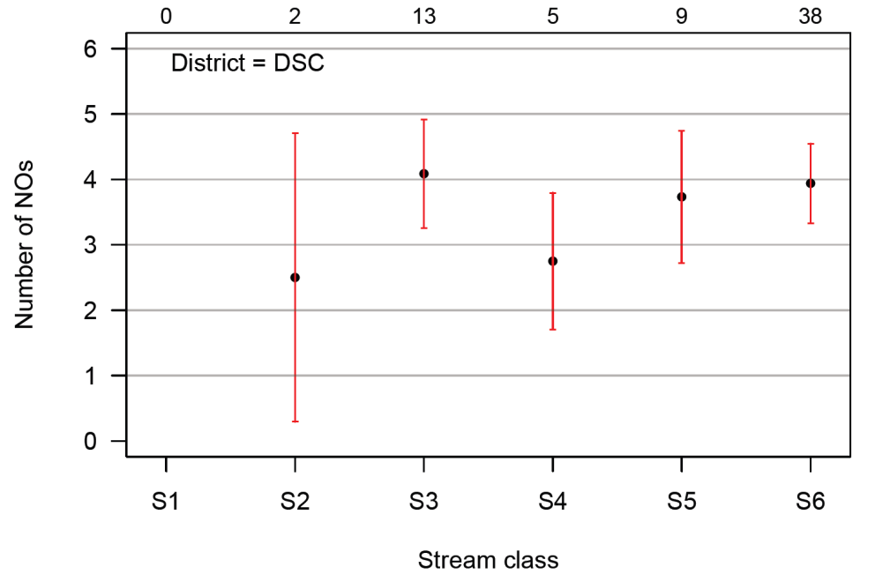
Figure 5. Estimate of Number of NOs within a district using Post-stratification of Stream Class (district selected: “DSC”). The number of samples within each stream class are shown above the graph.

Existing analyses within FREP program
The FREP program itself has performed a wide diversity of analyses with the monitoring data that has been collected, as exemplified in the FREP Report series. Other analyses of the FREP monitoring data are also demonstrated in some of the FREP Extension Notes. Additionally, substantial post-processing of the monitoring data is conducted to generate the Multiple Resource Value Assessment (MRVA) Reports for each of the districts and/or Timber Supply Areas.
Future data exploration and analyses of existing FREP data
The data set for the core FREP values (see Table 1) currently includes 8106 sampled cutblocks in 24 districts, spanning 10 years of data collection across 8 natural resource values. Although the level of coverage is variable across years, districts, and values, it represents a tremendously rich dataset nonetheless. Given its robust statistical design, stratified only by district and providing unbiased district estimates of performance measures, there are almost endless ways in which the data could be further analyzed or explored. Below are presented some preliminary ideas on areas for potential exploration, both generic and specific.
General potential for data mining
A recurring theme in the workshop was the sentiment that “we have barely scratched the surface” in terms of the potential information and understanding that could be extracted from the FREP data. Exploring and mining the data could easily occupy the time of a full-time analyst. The existing data could also support theses for multiple Master students which would be a cost effective way to leverage the existing data. Several potential examples are discussed later in this section.
Analyses suggested in workshop
A variety of potential post-stratification analyses were raised during the workshop. One stratification variable was stream class, which is shown in a simple example for one district above. These analyses could be performed at a district scale or provincial scale.
Feedback through both the survey and workshop demonstrated that there is a strong interest to explore the condition of different values by BEC zone (i.e., BEC Zone, BEC Subzone, or BEC Variant depending on the context), either across the range or focusing within particular zones. For the stand-level biodiversity value, BEC classification information is already included in the data. Table 2 shows how many BEC zones have sample data for the stand-level biodiversity data and how many zones have >10 or >20 samples.
Table 2. Number of BEC Zones, Subzones and Variants with greater than X cutblock samples for the stand-level biodiversity value. For example, there are 42 BEC Subzones that have greater than 10 cutblock samples.
 | Count with >0 samples | Count with >10 samples | Count with >20 samples
BEC Zone | 11 | 9 | 8
BEC Subzone | 65 | 42 | 30
BEC Variant | 114 | 63 | 39

For BEC zones that have thus far been sampled relatively few times, consider 1) that low sample size does not mean there is no information (see Section B.2 below), and 2) that this might be an appropriate targeted use of priority sampling (see Section B.6).
Linking with other data for other post-stratification
User feedback indicated a strong desire to be able to stratify on a range of potential stratification variables. Some of those variables are included in the FREP data and can therefore be readily used for post-stratification (e.g., stream class in riparian data, BEC in stand-level biodiversity data, as discussed above). However, the FREP cutblock sample data could be linked to other stratification variables based on external data sources. For example, GIS processing could be used to link sample cutblocks with data on their BEC zone. Other potential stratifying variables of interest to users included licensee size, block size, elevation, and watershed unit. These data are not integrated in the FREP datasets (e.g., stand-level biodiversity, riparian, water quality); however, they could be provided through additional analyses or by linking with relevant other data sources.
Using the detailed data within particular values
The MRVA reports (and the post-stratification example presented above) focus on key performance metrics. However, many different metrics are measured in detail within each value. Therefore there are opportunities to explore all types of detailed research and management questions by digging deeper into the data. For example, the key performance metric within the riparian value is Functioning Condition, but that assessment integrates the results from 15 questions (including further sub-questions) on a range of biological and physical attributes. Using that data, one could assess the relationship between particular biological and geomorphological conditions, and then examine how such relationships vary by stream class, or district, or BEC zone (if that extra GIS step is taken).
Examples of other potential questions or applications
The following list contains a few examples of potential questions or analyses for which the FREP data could be utilized. The possibilities are endless but these are merely a few concrete examples. Note that some of these analyses would require using both FREP and non-FREP data sources.
- Assess the difference in biodiversity outcomes and indicators based on the age of the pre-harvest stand.
- Determine the age of road system and evaluate the relationship with water quality outcomes.
- Assess whether there is a correlation between water quality outcomes and the level of training for equipment operators.
- Evaluate the degree of correlation of stream width within stream classes and outcomes.
- Modelling decay forward from known coarse woody debris and standing retention levels in different BEC zones.
- Assessing the species composition of retained trees compared to the pre-harvest inventory.
- Determine how much long-term retention (e.g. parks, Old Growth Management Areas, non-harvest Wildlife Habitat Areas or Ungulate Winter Range, riparian reserve) exists external to sampled cutblocks for biodiversity requirements, to assess if blocks with very low retention have been offset by nearby long-term retention.

As stated earlier, the possibilities for further analyses, data mining, and exploring new and complex questions are virtually endless. However, it does require resources either to directly pursue such work within FREP or to provide support for external analysts and researchers to be able to understand the data well enough to use it correctly.

Information at Low Sample Sizes
A very common misinterpretation of sampling data (in FREP, as with other monitoring programs) is the idea that when sample sizes are low they cannot provide any useful information. This is simply not true. The level of information provided by monitoring data exists along a spectrum from weak to strong (i.e., from low to high precision). When collected within a good sampling design, more data are always better than fewer data, but having some data always provide more information than no data.
With lower sample sizes, we must accept less precision in our estimates, but that alone does not mean those estimates are uninformative because the utility of the information also depends on the scale of effect we are interested in detecting. For example, although higher precision may be necessary to distinguish small differences in performance, even with low precision we may still be able to distinguish very good performance from very bad, which may be all that is needed to be informative in a particular context.
The purpose of this section is to provide some illustrative examples of the information that is provided at lower sample sizes, to increase the understanding that the relationship between sample size and information is not in fact black and white but is indeed characterized by a spectrum. We have predominantly used the riparian data to demonstrate these concepts.
Examples of precision vs. sample size using the riparian value
For the following examples, the performance measure being used is the number of “NO” answers within the 15-question FREP protocol for the riparian value. A greater number of NOs indicates poorer riparian condition and fewer NOs indicate better riparian condition. The protocol uses the number of NOs to determine the “riparian condition” of the stream; however, we are directly using the count itself as the performance measure.
Sample size and relative precision
For the riparian value example, Figure 1 shows how many samples a district would need to get within a certain percentage around the population mean (i.e., estimated by all of the samples for the district). The figure shows that with the observed population mean (3.4) and variance (5.75) of the number of NOs in the riparian assessments, a sample size of 30 within a particular district will result in an estimate that is within approximately 12% of the district mean. However, even with only 10 samples, the estimate would still be within approximately 22% of the district mean. With higher variance (e.g., 17) the estimate resulting from only 10 samples would be within 40% of the district mean, which is imprecise but not completely uninformative (this is demonstrated more intuitively by looking at absolute precision, which follows). With lower variance (e.g., 1) 10 samples would provide an estimate that would be within 10% of the district mean, which is reasonably precise.
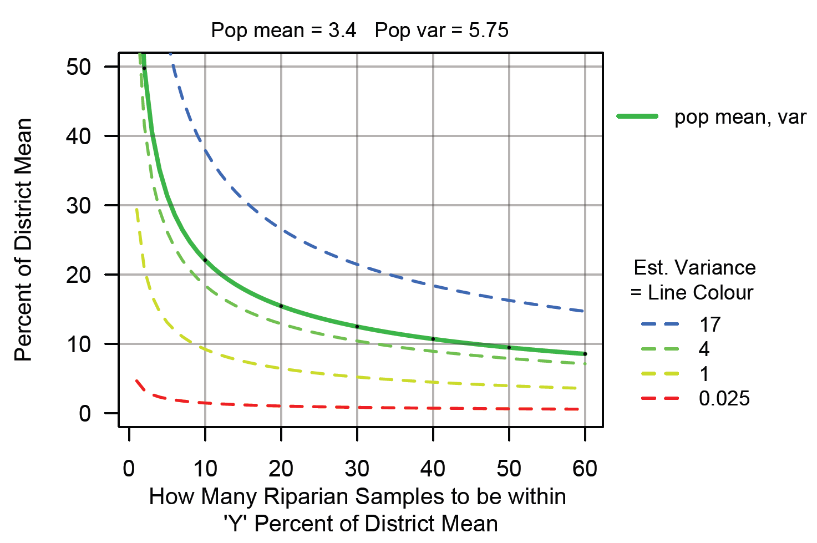
Figure 1. Exploring the relationship between relative precision around the district estimate of the “number of NOs” (riparian value performance measure) and sample size for different levels of variance.
Sample size and absolute precision
An alternate approach is to look at the effect of sample size on the width of the confidence intervals (absolute precision) (Figure 2). The results of this approach are likely more intuitive to understand because they align with how this performance measure is used to classify riparian condition (i.e., based on actual number of NOs). Using estimates of the mean from the riparian assessment of the number of NOs, and adjusting the underlying estimate of variability of NOs, we can see what the effect is on the precision of the estimate of mean (i.e., the absolute width of the confidence interval). Figure 2 shows that with the observed population mean (3.4) and variance (5.75) for the number of NOs in the riparian assessments, a sample size of 20 within district d will result in an estimate that is within (i.e., plus or minus) 0.5 NOs for the district. A sample size of only 6 will give an estimate that is ±1 NO for the district, which is sufficient precision to estimate the riparian condition to be within the range of two of the classes (defined in earlier footnote). Even with substantially higher variance (e.g., 17), 5 or 10 samples would result in an estimates with a precision of ±2 or ±1.25, respectively. Although it would not be possible to distinguish between adjacent riparian condition classes, these estimates are still sufficiently precise to distinguish between the extremes. That is, if 5 samples result in an average of 6 NOs with high variance (e.g. 17), it will not be possible to conclude which of the three poorer performing classes is most accurate (i.e., 6 ±2 NOs) but one can be confident that the true mean condition is not “properly functioning” (i.e., 0-2 NOs). Conversely, if the 5 samples resulted in an estimate of “properly functioning”, it would be imprecise but one would be confident that the true mean condition was not “not properly functioning”.
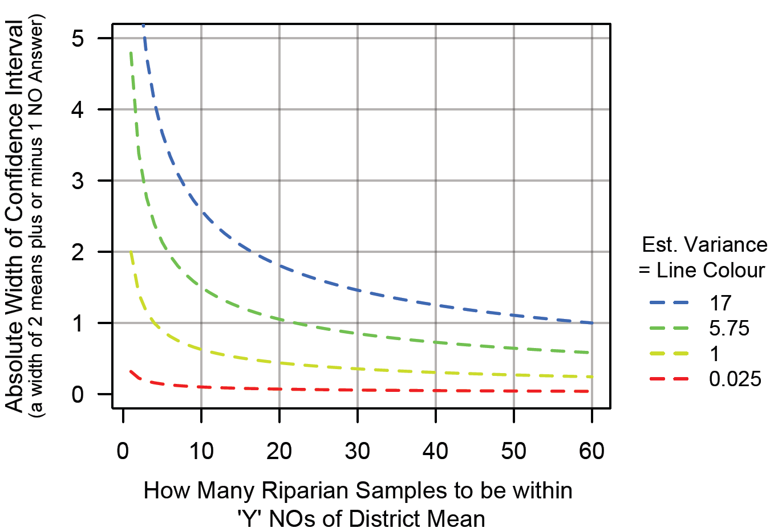
Figure 2. Exploring the relationship between absolute precision around the district estimate of the “number of NOs” (riparian value performance measure) and sample size for different levels of variance.
Sample size and sampling fraction
The relative fraction of the population that is sampled is commonly misinterpreted to be a more important factor in determining precision than it truly is. Precision depends significantly on the absolute sample size, and not on the relative fraction of the population sampled. In Figure 3, we show the effect of sampling fraction, to demonstrate that the relative fraction of the population sampled has very little effect on the precision of the estimator (unless you sample all cutblocks within a strata, or close to it), but rather precision depends predominantly on the absolute sample size. The sampling fraction, as represented by the different lines for different population sizes (N), has substantially less impact on the precision (i.e., percent of district mean) than increasing the sample size (until sample size is much larger and the sampling fraction starts to approach a census).
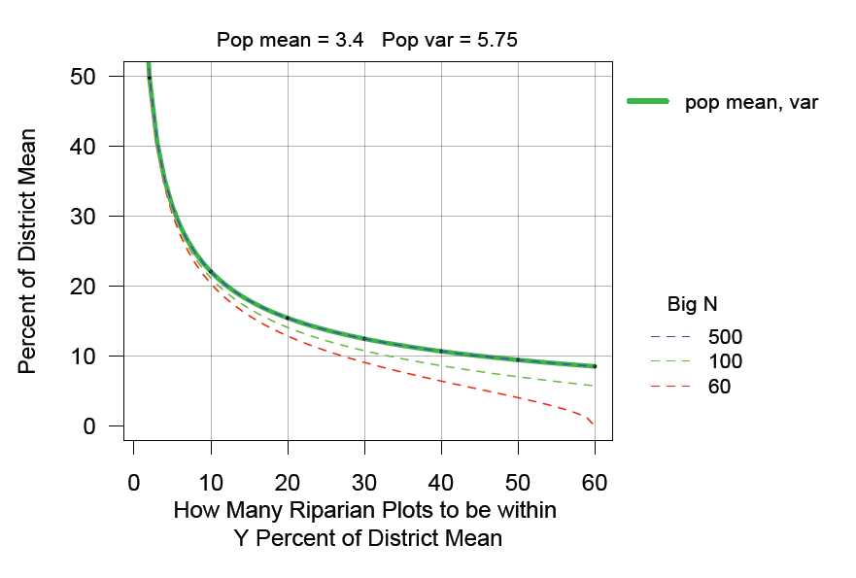
Figure 3. Exploring how sampling precision (i.e., estimate of the district mean as percent of district mean) varies with sample size and sampling fraction (i.e., proportion of the population sampled, n/N). The example uses the “number of NOs” from the riparian data as the performance measure. “Big N” is the population size.
Sample size and standard error
Figure 4 provides an example of the relationship between sample size and standard error, in this case for an individual generic district. The standard error (SE) measures how variable the results of our survey would be if the survey were to be repeated. Note that standard error decreases substantially with increasing sample size, even when sample size is still less than 10. Even just increasing from a sample size of 3 to 6 reduces the standard error from approximately 4.3 to 3.7. The estimate based on a sample size of 6 cutblocks is not as precise as those based on higher sample sizes, but it is still an improvement from estimates based on fewer samples. The estimates with lower sample size are less precise but they still provide information.
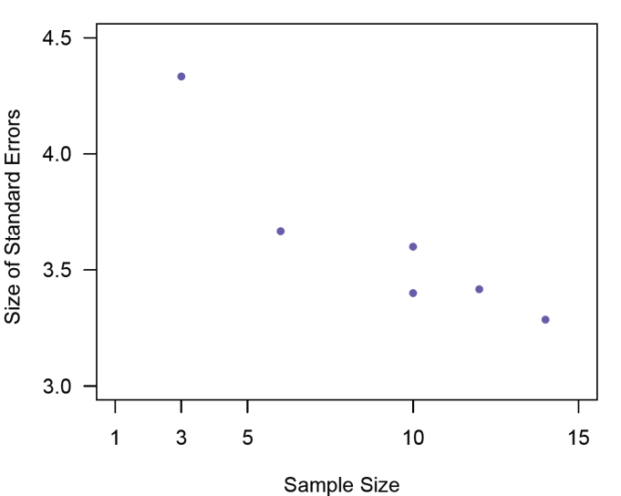
Figure 4. A generic district-specific example of the relationship between the precision of the estimator (standard error) and sample size. This example uses the “number of NOs” from the riparian data as the performance measure.
Examples of precision vs. sample size for a proportional pass/fail metric
Below is an example of the relationship between precision and sample size for a proportional pass/fail metric. For example, various measures of resource condition might be rolled up into an indicator used to estimate the proportion of the population in “red” or “green” condition. Table 3 shows the number of samples required to estimate the proportion of sites in pass or fail condition for both 90% and 95% confidence levels and confidence interval widths ranging from ±0.05 to ±0.15, as calculated for different proportions.
The calculations for a proportion of p=0.5 provide the most conservative estimate. That is, when the proportion is closer to 0.0 or 1.0, then the sample size required for a given confidence level and confidence interval width is less, as demonstrated for p=0.2, 0.8 (i.e., the calculation is the same for these two proportions). The results show that to achieve the highest level of precision when p=0.5 (i.e., 95% CI and CI width of 0.05), a large sample size (n=385) is required, but substantially fewer samples are required if one accepts a slightly lower confidence level or wider confidence intervals. That means that estimates based on lower sample sizes will be less precise, but they still provide useful information.
Table 3. Number of samples required to estimate the proportion of pass/fail sites with different confidence levels and widths, assuming different true proportions.
For p=0.5 | Confidence Interval Width
Confidence Level | 0.05 | 0.1 | 0.15 | 0.2 | 0.3
95% CI | 385 | 97 | 43 | 25 | 11
90% CI | 271 | 68 | 31 | 17 | 8
For p=0.2, 0.8 | Confidence Interval Width
Confidence Level | 0.05 | 0.1 | 0.15 | 0.2 | 0.3
95% CI | 246 | 62 | 28 | 16 | 7
90% CI | 174 | 44 | 20 | 11 | 5

For example, consider the situation where the primary concern is to understand whether a population (i.e., district, region, etc.) has a high rate of failure on a particular indicator (i.e., p, the proportion of “passes” or “green” condition is low). If the true proportion is p=0.2 (i.e., 80% failure of sites), then even only 20 samples would provide a 90% confidence estimate of 0.2 ±0.075. The data thus indicates that there is only a 10% probability that the confidence interval would not contain the true proportion – in other words, even 20 samples would provide strong evidence of poor performance. If the primary concern is identifying whether there is a high failure rate, it may be perfectly acceptable to have wide confidence interval widths and therefore even quite small sample sizes could be informative. For example, if 7 samples generated an estimate of p=0.2, the estimate would have a 95% confidence interval of 0.05-0.35. That is a wide confidence interval, but if for example the regional target for overall “success” was p=0.5 (or any higher target), these 7 samples would provide sufficient precision to conclude that the population is very likely not meeting that target. Knowing the true proportion more precisely is not necessary for conclusions about that broad scale of effect. Conversely, if the 7 samples generated an estimate of 0.8, then the estimate would have a 95% confidence interval of 0.65-0.95, providing sufficient confidence to conclude that it is very likely that the population is meeting the target and does not in fact have a high rate of failure.

Component II: Allocation of annual samples to core FREP design

Summary of Approach
The fundamental premise of this component is the requirement that the level of sampling conducted for each value within each district meets a minimum threshold within a rolling window, in order to achieve and maintain full implementation of the core FREP design.
The key requirements (with rationales described in Section B.4) are:
- The minimum threshold is 30 samples per value per district;
- The rolling window in which the minimum threshold must be achieved is 5 years;
- This applies to 7 values for all districts, plus 1 additional value for 5 districts;
- Each value does not need to be sampled each year, but must not have a gap of more than 2 years;
- The frequency and intensity of sampling necessary to achieve the defined minimums is otherwise flexible.

Rationale

Rationale for overall approach
The overarching rationale for this approach is to achieve and maintain full implementation of the core FREP design, including providing coverage both across values and over time.
Sampling coverage across values
One of the ultimate goals of the original FREP design was to be able to monitor the condition of the identified resource values across districts and rolled up to the regional and provincial scales.
FREP has now been active for 10 years. However, the level of sampling has varied among values and districts over this time. Sampling for different values began at different times and implementation across districts has been uneven. In 2006, only 2 values (occasionally 3) were being sampled within each district, but by 2009 almost all districts were sampling 3-5 values per year and from 2011 onwards most districts have been sampling 4-6 values per year (Table 4). The actual number of cutblocks sampled for each value in each year is shown in Table 5, including the totals by value for the earliest five years and the latest five years. The results in Table 5 show the following broad patterns:
- the riparian and stand-level biodiversity values were sampled much more heavily in the early few years than subsequently;
- the water quality and visual quality values have been sampled more in the second half of the record than the first, though with decreasing frequency more recently;
- the stand development monitoring value was sampled increasingly frequently from 2009 to 2013 but annual sampling has fallen by half since then;
- the cultural heritage resources value has seen substantial, steady increases in sampling but still remains much lower than the above-mentioned values; and,
- the wildlife and karst (only applies to five districts) values have had relatively minimal sampling thus far.
However, these tables do not show the substantial inter-district variability that exists. That is, some values have been sampled extensively in some districts and minimally in others and other values have limited sampling across many or most districts.
Table 4. Number of FREP values sampled in each district over time.
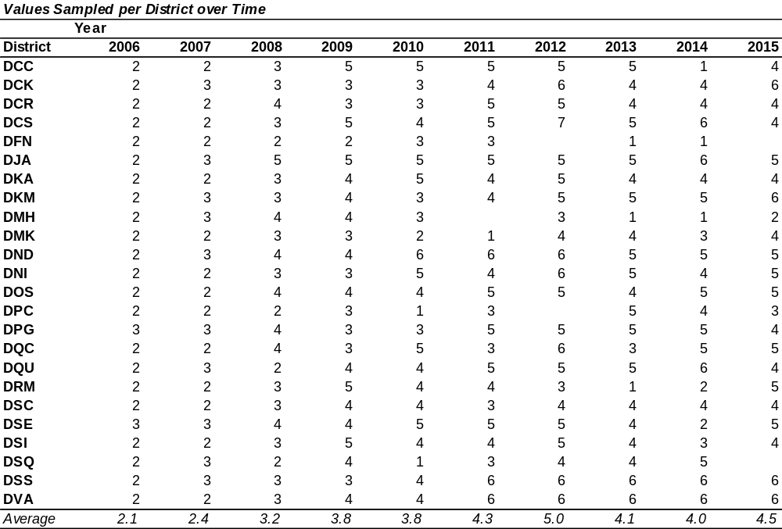
Table 5. Number of cutblocks sampled per value (across all districts) over time.
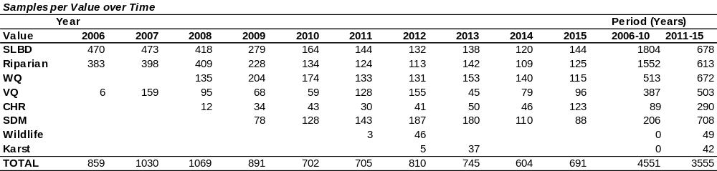
Sampling coverage across time
Requiring that a minimum level of sampling effort is maintained within a rolling window is a relatively simple design to address some of the major components of the temporal issue, which has not yet been explicitly addressed by the FREP program. However, given its stage of development, it is not unexpected that the focus thus far has been on implementing the original design and expanding it across FREP values.
The issue with time
Time is a confounding variable. Weather, hydrologic condition, climate patterns, biological cycles, and management practices can all change over time. It is important to continue to collect newer samples because older samples may no longer be appropriate to represent current conditions.
Using a rolling window
Establishing sampling requirements within a rolling time period ensures that the data collected through the program is continually updated. The FREP program has sometimes received criticism for the use and/or reliance on older data. This design feature is a significant advancement because it forces the sampling program to keep data collection current.
Using older data
Although older data is “dropped” from the rolling window being applied to ensure ongoing collection of updated data, the older data is not lost and continues to be valid for the period in which it was collected. All of the data (recent and older) is maintained in the database and thus still allows comparisons to be made between periods and/or analyses within particular windows of interest. Ongoing sampling will also allow trend analyses to be conducted. By ensuring a minimum level of data in every 5 year period going forward, this design enhances the ability to perform such temporal analyses in the future.
Allowing flexibility
Establishing minimum sampling requirements within a rolling window, as compared with an annual threshold, gives districts flexibility in deciding how to achieve the minimums across values.

Rationale for specific elements of design

Number of values
This framework is intended to apply to seven of the FREP values (stand-level biodiversity, riparian, water quality, visual quality, cultural heritage resources, stand development monitoring, and stand-level wildlife) for all districts, plus karst for five districts. These are the core FREP values, as defined in Section B.1.

Number of samples
Minimum target
We have recommended using 30 samples as the minimum target to be achieved by value within the 5-year rolling window, based on statistical and logistical considerations. In sampling design, n=30 is a commonly used a rule of thumb because the mean of sampled data starts to approximate a normal distribution when n>30. A sample size of 30 is therefore generally large enough to be able to make some conclusions. This also aligns with existing FREP guidance, which identifies a target of 30 samples per value for MRVA reports (see FREP Technical Note #6) to “increase precision and account for variability”. Additional support was provided through a preliminary review of the FREP data for the riparian value, which showed that district estimates of the mean and standard deviation of the performance metric (i.e., number of NOs) were still highly variable when n<20. The estimates for many districts began to stabilize with n>30 but some did not stabilize until they had 40 or 50 samples. A cursory review of key performance metrics for the stand-level biodiversity and water quality values showed similar broad patterns. However, feasibility is also a critical factor. A target of 30 samples is achievable and although some districts/values could require much higher sampling to achieve similar levels of precision, such levels do not appear to be currently feasible given resource constraints. We recommend starting with a uniform target rather than starting with different targets for every district-value combination.
As the recommendation must apply across all districts, values and PMs, a minimum target of 30 is a good initial starting place. Our experience from other monitoring programs is that starting with a reasonable initial target (i.e., simple, achievable, and robust) that is sufficient to move forward is more critical than trying to determine the “perfect” set of targets, as the costs of the additional complexity can easily outweigh the benefits, especially if it results in delayed implementation. As additional data is collected, especially for those values with limited data currently, this target can be re-evaluated based on the variability within districts and values. Setting a uniform target across values does not preclude future modification because it does not change the core design.
Ultimately, users want to know when they have “enough” data to answer their questions. However, this question cannot be comprehensively addressed because there are too many questions of interest, some are not well-defined and many values do not yet have sufficient data to fully understand the variability in the data. For specific, well-defined questions, power analyses could be used to determine how much data is necessary to answer the question. The ultimate objective of power analyses is to understand how successful a sampling design will be at correctly detecting an effect when that effect has indeed occurred, and how likely it would be to 1) falsely conclude that an effect has occurred when it has not, or 2) fail to detect an effect when it has actually occurred. Power analyses require having a clearly defined question and estimates of how variable the data is. It is also important to understand the level of precision that is required by the end users (e.g., how will the precision influence the conclusions or decisions based on the data). However, conducting power analyses can be very complex and involving even for a single question; therefore it would be infeasible to perform power analyses for all of the questions for which the FREP monitoring data are used. Such analyses may also reveal that the level of precision that is desired by users cannot be achieved with existing levels of data collection (e.g., previous power analyses conducted within the FREP program; W. Bergerud, pers. comm.).
As discussed in Section B.2, sample size is much more important in determining the precision of the estimate than the sampling fraction (i.e., sample size as a proportion of the population size, n/N). The relevance to the current situation is that even though the population size (N) varies from 100s to 1000s among the districts, those differences are not as important to the precision of the district-level estimates as the sample size (n), which in this case has been recommended as n=30. Although some districts have a much larger population size of cutblocks, they do not inherently require a larger sample size to generate an estimate with an acceptable level of precision, and conversely, it is not appropriate to reduce the sample size for those districts with smaller population sizes.
Using 30 samples as the minimum target to be achieved by value within the 5-year rolling window will provide good information for moving forward and can be further evaluated in the future.
Inter-annual frequency of sampling value
The sampling frame for most of the FREP values is based on cutblocks that have been harvested within the previous three years. An important statistical principle for the sampling design is that every eligible cutblock must have a chance of being selected for sampling, which means the frequency of sampling each FREP values needs to be at least every three years to achieve this requirement. This principle is echoed in FREP Technical Note #6, which describes that part of the rationale for using a rolling population was to provide redundancy such that even with little or no sampling in a particular year, every harvest year still had the potential to be sampled. Therefore our recommendation is that for each value in each district, sampling can occur annually or with gaps of 1-2 years. The temporal allocation of samples for each value can be variable as long as they are sampled a minimum of every third year and meet the minimum total samples within the 5-year rolling window.
This approach gives districts flexibility in their planning as long as the minimum totals and minimum frequency are achieved. For example, districts will have the flexibility to alternate among the values if beneficial. In particular, this could provide useful flexibility around training requirements. Concerns with the time and resources required for training were raised in the survey results and workshop discussions. The present approach would allow districts to determine if there could be efficiency gains from strategically planning the sampling of certain values. For values that require substantial new training each year they are implemented, districts could opt to sample every 2-3 years, thus limiting the high training costs (e.g., time, funding, initially slow productivity) to fewer years. However, districts might also determine that for certain values sampling annually is the best approach. Either way, districts would have the flexibility to evaluate those tradeoffs.

Size of rolling window
The appropriate time frame to use should be based on an understanding of how biological and management attributes change over time, in order to define an appropriate window for characterizing “current” condition. A five-year window has been selected based on expert input from the FREP advisory team. The FREP program has received criticism about data that is greater than 5 years old being out of date with respect to representing current conditions, therefore a 5-year window will ensure data collection is kept current. However, any window smaller than 5 years is likely to be too narrow for logistical reasons – that is, achieving the minimum number of samples per value within the window would be infeasible given realistic levels of effort.
As more data is collected, especially for values with less historic sampling, the definition of the rolling window can be evaluated quantitatively and compared with alternate lengths. A key factor for determining the appropriate window is understanding how quickly potentially confounding factors change over time. These changes could include directional shifts, such as climate change trends or changes in management actions, or cyclical patterns, such as climate oscillations or natural biological cycles. However, 7-10 years of data (varying by value) is insufficient for rigorously assessing whether multi-year to decadal temporal cycles exist. We cannot therefore conclusively evaluate the appropriate window size with the existing data at present. Additional years of data are required to be able to quantitatively identify temporal cycles. For now, it is appropriate to use an expert-defined window as a starting point. This definition of the rolling window can be adjusted in the future as further learning occurs.
It should be emphasized that requiring a minimum number of samples within a rolling window is a way of structuring data collection, but it does not impede the ability to perform analyses over broader time periods. As noted earlier, the older data is not lost and remains valid for the time period in which it was collected. Reporting and analyses can be performed over different windows as necessary. A user could evaluate the differences between periods or analyze trends over time. The rolling window minimums simply ensure that recent data continues to be added to the data set.

Implementation
We have developed a simple, prospective planning tool to help allocate future sampling efforts across values such that the minimum sampling requirements evaluate whether those sampling plans will achieve and maintain the target minimums and allow the level of effort across years to be balanced in a feasible way. Plans are not locked in place and are expected to evolve as unanticipated constraints or opportunities arise. However, it is critical to plan well ahead, to anticipate and account for large “blocks” of sampling “falling out” of the rolling window. Otherwise, the sampling rate may be erratic over time.
The suggested approach for effective, proactive planning includes four steps:
- Identify what the ideal sampling frequency by value needed to maintain alignment with the minimums would look like and enter this is the latter half of the planning window (i.e., 2020-2025). As described earlier, this does not necessarily have to be uniform, annual sampling and may vary by value, as determined by the district.
- Work backwards over the first half of the planning window to determine sampling required in next few years to successfully bring the current the sampling record into alignment with the desired longer-term sampling patterns and the required minimums.
- Make adjustments as necessary to resolve any potential issues (e.g., cumulative total sampling within a particular year is predicted to be infeasible).
- Revisit each year. Update the sampling record for the past year, confirm whether the prospective plan is still appropriate. Adjust as necessary.
Several examples of sampling plans developed through this prospective approach are provided in Appendix 3, including a district with high sampling in recent years, another district with very low sampling in recent years, plus a few alternate allocations of sampling effort for a single district to demonstrate the flexibility permitted.
By contrast to the proactive approach, a reactive approach would fail to look at the longer term planning window and only consider the immediate context. Reactive planning leads to a more variable prospective sampling record because it does not consider the effects of existing large “blocks” of samples in the sampling record until they “fall out” and need to be replaced immediately, and it does not consider unintended creation of such blocks in the record. At the extreme, the most reactionary planning would only consider the upcoming year and would preferentially direct all sampling efforts to the values furthest below their minimums (see final example in Appendix 3).

Component III: Allocation of annual samples for district-level priorities

Summary of Approach
As long as the minimum core sampling for provincial design is being achieved (as described above), then any additional sampling effort can be directed toward district-level priorities. Assessing the right approach for addressing a specific priority and developing an appropriate sampling plan requires a careful, systematic approach and use of the FREP protocols to ensure that the data collected with these “priority samples” will be informative both to districts and regions and to the provincial design. This should include consulting with a statistician to develop and/or review the proposed design.

Rationale
The primary focus of the FREP program is to implement the core design across all districts. However, a dominant theme that emerged in the feedback collected through the survey and workshop was the interest of districts to direct sampling effort toward local priorities. As discussed elsewhere, our conclusion has been that it would not be appropriate to modify the overall sampling design to address these district-specific priorities because they vary substantially among districts, they may change over time, and any specialization of the sampling design (e.g., pre-stratification, subsampling, preferential selection, etc.) would be at the expense of the flexibility of the overall provincial design. However, in order to accommodate this interest, the proposed approach allows districts to have some flexibility in addressing local priorities as long as the minimum sampling requirements for the core design are achieved.
A central caveat to this approach is that it assumes that the resources available will support a level of sampling that is greater than that which will be required to maintain the minimums. Once the minimums are achieved, the difference between the total number of annual samples and the number needed to maintain the core design provides the opportunity for “surplus” samples available to be used for local priorities. However, even if there is no surplus FREP funding, it is to the districts’ advantage to follow these basic sampling principles and where possible to collect data that is compatible with the FREP design to provide greater context for district level findings.

General Guidance on Implementation of Priority Sampling
When determining if and how to allocate priority samples to address district-specific questions, districts should consider the following steps. These steps provide a generic process to follow, rather than a detailed guidebook or prescriptive template, which is beyond the current scope. Each question in each district will vary in important ways that can fundamentally influence the optimal sampling design (e.g., scale of the question, temporal dynamics, required precision, sample and population sizes, how the data will be applied to management decisions, etc.). However, the following provides a summary of core concepts for good sampling design. When addressing district-specific priorities, districts should both consider these issues and consult with an expert in sampling design.
- QUESTION: What is the question of interest?
  - It is critical that the question is clearly defined
    - What are the outcome(s) or performance measure(s) of interest?
    - Under what conditions and/or in what types of sites?
  - What level of precision/power is acceptable? (i.e., provides the level of confidence necessary for the information to be useful)
  - What time period is acceptable?
  - Consider the tradeoffs among precision/power, time, and sample size:
    - e.g., If precision/power needs to be higher, then you need a larger sample size, which requires either more samples per year or more years
    - e.g., If samples per year cannot be increased, then there will be a tradeoff between precision/power and the number of years required

- EXISTING DATA: How much data relevant to addressing this question is currently available?
  - Also consider future data likely to be collected (i.e., anticipated sampling)
  - Is there (or will there soon be) sufficient data to address the question without additional sampling (e.g., post-stratification)?
  - Are there sufficient data to inform the development of a sampling plan and/or to help refine the question?
    - e.g., preliminary estimates of variance; preliminary conclusions with low precision; data only lacking for certain sub-strata

- SAMPLING DESIGN: Determine appropriate sampling design
  - Define the question (as above)
  - Define the population of interest
  - Define the strata of interest (e.g., rare or special strata; BEC subzone or variant)
  - Define the sampling unit (cutblock, as per FREP sampling design)
  - Define the sampling frame
    - In general for sampling design – sampling frame must be rigorously defined, documented, repeatable, and identify whether it is static or dynamic
      - For FREP funded projects – it should be a subset of the existing sample frame
        - Temporal definition – same as existing sample frame (i.e., ≤3 yrs since harvest)
        - Spatial definition – may be limited to strata of interest
  - Selection method
    - Probability sampling should always be used – every sampling unit in the sample frame must have a known probability of being selected (i.e., inclusion probability).
    - If the inclusion probability is known, then it is possible to weight the samples appropriately and ensure valid inference is possible. With a simple random sample (the original FREP design) all cutblocks within each district have the same inclusion probability and are weighted equally. When specific categories (i.e., strata) or sites are targeted, the inclusion probabilities and weights are no longer equal, for example:
      - A district wishes to use all of their surplus sites on a specific BEC zone, this data can still be used for the provincial records, but will be weighted differently (less weight) from cutblocks of the same BEC zone selected randomly (greater weight).
      - If a district knows of a particular cutblock which is of concern to them, they may sample this cutblock, but the inclusion probability will be 1 for this cutblock and zero for all others, therefore the data from the ‘special’ cutblock can only be used to describe that cutblock, no inference can be made to other cutblocks.
    - In general, the greater the inclusion probability, the smaller the population they can be used to inform and the less valuable the samples will be to the Provincial FREP questions (i.e., sample weight is inversely proportional to inclusion probability).
  - Sample size
    - Will be dependent on how much sampling effort is available beyond obligations to the core FREP sampling
  - Define how the resultant data will be stored
  - Define how the resultant data will be analyzed to answer the initial question

NOTE: The greater the consistency (e.g., sample unit, sample frame, and protocol) between other programs (e.g., Fisheries Sensitive Watersheds) and the FREP sampling design, the greater the ability to share data and personnel, and therefore the greater the mutual benefit.

- EVALUATE BENEFIT: Will it be possible to adequately answer the question?
  - Will the sampling design for utilizing the prospectively available “priority samples” provide an acceptable level of precision or power?
    - If not, can the question or design be modified to increase precision/power (e.g., adding more samples, per year or over more years)?
    - Or, is the lower precision/power acceptable (e.g., still provides useful information)?
  - If sampling will be insufficient to answer the question with an acceptable level of precision, consider other approaches for addressing the question (e.g., do not waste sampling effort on collecting inadequate information)

- EVALUATE COMMITTMENT: Is the district committed to addressing this question and to collecting the necessary data over the required number of years?
  - Will the districts priorities change over a shorter period than that required to collect sufficient data to address this question?
  - Must have commitment to direct surplus samples to this question for X years (i.e., however long is necessary to get the desired info)
  - Must not be a short-lived priority (i.e., ad hoc priorities that change every year or two)

- DATA COLLECTION: Plan and implement data collection
  - Only if “yes” to both decisions in #4 and #5
  - Must use existing FREP protocols to ensure compatibility

Obtaining context-specific statistical advice
Establishing a sampling design with limited annual samples that will effectively contribute both to addressing district-level priorities and the provincial FREP design is complex. The above sections provide some high-level guidance on some of the most relevant considerations but specific approaches will depend on the nature and context of the questions being asked. It will be important to consult with a statistician and formal texts (e.g., Cochran 1977; Lohr 1999; Thompson 2002) to confirm that the design is appropriate for the specific goals of the district and can still contribute information to the provincial design.

Integrating data from priority sampling with provincial FREP data
Following the above principles and guidance will lead to the highest likelihood that the data collected from district-specific priority sampling can be integrated with the data from the core FREP sampling program, and thus be used to contribute to district, regional and provincial estimates. The specific statistical calculations necessary to integrate these data into the larger data set will depend on the specific characteristics of the sampling design under which the priority samples are collected. The computation necessary to integrate these data is not “one size fits all” because the sampling designs potentially used for the priority sampling will not be “one size fits all”. However, as long as the guidance on sampling design outlined above is followed and thoroughly documented (i.e., the inclusion probabilities are known), it should be possible use the priority sampling data with the data from the core design. Again, as with the approaches to be developed for addressing individual priority questions, the details are statistically complex and will require consultation with a statistician to ensure the data are used correctly and to avoid common pitfalls (e.g., treating the priority samples the same as the randomly selected samples across the district collected under the core design, a form of pseudoreplication (Hurlbert 1984)).

OTHER DESIGN OPTIONS CONSIDERED
The March 2015 report identified several options to be considered for potential modifications, based on input from users through the survey and workshop. Those options have not been recommended as changes to sampling design. The previous report described the basic premise of each of the options, the rationale for considering each, and some of the tradeoffs. This section does not repeat that context, but focuses on the rationale for our conclusions that these options are not appropriate modifications to make to the sampling design at this time.
Stratification
Stratification of the sampling design (i.e., beyond stratification by district) could be beneficial if there was a single potential stratification variable of common interest to users and strongly associated with the questions of interest. In that case stratification could potentially improve the design if the variability between strata was greater than the variability within strata and some strata were being undersampled in the existing design. However, what we have learned through the survey and workshop was that there are too many different questions (and therefore potential stratification variables) of interest to different users. Although users commonly expressed support for stratification as a “solution” to needs not being met, we believe that such an approach would be in conflict with many of the needs of users currently being met by the existing design. Given the breadth of questions, interests and priorities, we do not believe it would be possible for the FREP user community to agree upon a single, additional stratifying variable. Furthermore, stratifying by one variable to better address one set of questions would be at the expense of the ability to address other sets of questions, possibly trading off the needs of some users against the needs of others, thus undermining one of the greatest strengths of the existing sampling design – flexibility. Stratifying based on all or many of the variables of interest would make the provincial design impossible to work with. There is no such thing as a perfect design that can do everything for everyone, but a simple design maintains options to analyze the greatest breadth of question (including new questions that have not yet emerged).
As presented at the workshop (see Wendy Bergerud’s presentation in the appendix of the March 2015 report), the original architects of the FREP sampling design did in fact consider the pros and cons of further stratifying the design beyond the main stratum of district. They considered a range of potential stratification variables such as BEC zone, block size, licensee, and others. However, multiple factors led to the conclusion that further pre-stratification was not desirable:
  - FREP is an effectiveness program, not a compliance and enforcement program;
  - It could not be determined whether any possible pre-stratifying variable would actually be effective at improving the efficiency of sampling;
  - Pre-stratification, and in particular, inappropriate pre-stratification, would increase analysis challenges, especially with any desired post-stratification;
  - Data analysis within a district is simplified by using Simple Random Sampling (SRS);
  - Avoiding additional pre-stratification allows more freedom to choose post-stratifying variables without complicating the analyses; and,
  - Cutblock area is an available variable for those wishing to do area-weighted estimation.
For some of the values, there is now sufficient data to address #2. However, because the other reasons still provide sound justification for not adding further stratification to the core design and resonate with user concerns associated with potential changes to the sampling design, we have not further evaluated that possibility. Because there is such a breadth of questions of interest, including new questions that may emerge in the future, and many different stratifying variables of interest to users, it does not make sense to optimize the design for one type of question at the expense of others.
However, with a complex sampling program such as FREP with competing goals, and with goals that evolve and change over time, it is difficult to imagine a stratification beyond the spatial one already implemented (with districts as strata) that would result in a variance reduction while preserving proportional allocation of effort across the diversity of habitats within the province.
Risk
Many users have interest in being able to stratify the FREP sampling design based on “risk”, as expressed through the workshop, survey and other previous engagement.
Our conclusion about incorporating risk into the FREP sampling design as a stratifying variable remains the same as was expressed in the March 2015 report. Although the interest in “stratifying based on risk” is widespread, there is no common definition for “risk”. The Cumulative Effect team continues to work on developing broader, more unifying potential definitions of risk across the entire landscape but the work is not yet advanced enough to incorporate into the FREP program, especially not as a basis for the core sampling design. As recommended in the March 2015 report, the pragmatic approach to incorporating risk as a stratifying variable would be to develop a uniform definition that can apply across all values. By contrast, having a unique definition for risk for each value would add a tremendous level of complexity to the design and subsequent analyses.
Currently, there are still debates among different ways of defining risk even for different elements within a single value, never mind approaching agreement on a common definition across all values.
Even if it is possible to develop a uniform definition of risk across all values, other complications remain. For example, can the level of risk for a given part of the landscape change over time? If so, the stratification would not be static, and the statistical implications of a temporally dynamic stratification are highly complex. In that case, it would be important to critically assess whether the potential benefits would truly exceed the increased costs.
We believe that this topic should continue to be considered as the Cumulative Effects team advances their work on defining risk, but it is currently premature to consider integrating “risk” as a central dimension of the core FREP design.
Subsampling
In the March 2015 report, subsampling was identified as a potential design option to further consider, based on input from the survey and workshop. As described in the report, the two primary reasons for including subsampling as an element of a sampling design are 1) to increase efficiency, or 2) to address secondary questions. Subsampling is not recommended because it is likely that there would be limited or non-existent gains in efficiency while reducing the effective sample size for district estimates. Similarly, given the realistic range of sampling effort, using subsampling to address secondary questions would likely drastically reduce the effective sample size for district estimates, thus undermining a core component of the design.
Subsampling to increase efficiency
In simple terms, statistical efficiency considers the tradeoffs between improving the estimate of a performance measure (e.g., lower estimation error) and the level of effort required to achieve that improvement. In the case of subsampling, the question is whether the additional effort involved in sampling SSUs nested within each PSU would result in sufficiently substantial gains (i.e., improving the precision of estimates of performance measures). The level of effort must consider both the time to travel between sampling locations and time required to complete the protocol at one sampling location.
One aspect that can be important when developing a sampling design can be the time and money to collect the samples. For example, if the cost (effort) of traveling between PSUs was quite high, but once someone was there the costs of completing the protocol and traveling between SSUs was quite low, then subsampling might increase efficiency – that is, increase the precision of the estimates of performance measures at each PSU (which improves the estimate for the population) with only low additional effort. However, if the costs of traveling between SSUs and/or the costs of completing the protocol were quite high, then subsampling might not be economical. In this case, the gain in precision of the estimate of each PSU may be achieved only with substantial effort and, given fixed overall resources, at the expense of sampling fewer PSUs. If the ultimate interest is to provide a better estimate with lower estimation error for the population estimate, that additional effort would be better spent sampling more PSUs and increasing the sample size. In particular, when the cost of traveling between PSUs is not high, increasing the number of PSUs has higher gains in estimation efficiency when compared to subsampling fewer PSUs. A careful consideration in survey design is the trade-off in the precision of the population estimate, and the distribution of effort required for collecting the data.
In the case of FREP, the cost of traveling to different PSUs within the district can be quite high. Therefore, subsampling could be useful if multiple samples could be done per day and the cost of travel between potential SSUs was not high. However, the FREP sampling protocols are substantial and often only one sample, possibly two, can be done per day. Furthermore, field experience from the Fisheries Sensitive Watershed project has shown that the travel cost can be significant even between two relatively nearby sites within a watershed. If each additional sample usually requires a full day to provide sufficient time for travel and sampling, then there is minimal potential for efficiency gains by adopting a subsampling design – that is, there may be improvement in the estimate for the populations, but at significant cost and at the opportunity cost of sampling additional PSUs instead.
Subsampling to address secondary questions
A second purpose for subsampling is to address questions at a secondary scale. For example, in FREP the primary scale of inference is the district, whereas a potential secondary scale could be watershed. Given that it is improbable that more than a couple samples would have been randomly selected in a particular watershed as part of the core sampling design, targeted subsampling would be required to collect enough samples to be able to make meaningful inference to the condition of the watershed. In this example, watersheds would be the PSUs and cutblocks within each watershed would be the SSUs.
However, for a fixed sampling budget, the more effort directed toward sampling SSUs, the fewer PSUs can be sampled. Thus redirecting limited resources from PSUs to SSUs reduces the sample size for District-level estimates. For example, in the Fisheries Sensitive Watershed program, to adequately characterize watershed function (i.e., sufficient sample sizes to observe some degree of variance stabilization) required approximately 30-40 samples. Therefore, if a District with resources to conduct 30 samples for a particular value focused that effort in a single watershed instead of being distributed across the district, they would be making a substantial trade-off – gaining a good understanding of that single watershed at the expense of having the ability to make any inferences to the whole district (i.e., there would be only 1 PSU for the District). In that extreme case, the primary intent of the program would be entirely undermined. Therefore, our conclusion is that modifying FREP to be a two-stage sampling design to answer questions at both the primary scale (District) and a secondary scale (e.g., watershed) would not be possible given the levels of sampling effort currently conceivable. For example, sampling 30 SSUs within two watersheds plus 30 PSUs is beyond what is realistic. Sacrificing the ability to make inference to the district level in order to answer questions at a secondary scale is not an appropriate trade-off. Addressing questions at specific sub-district scales will need to be addressed within other focused programs (e.g., Fisheries Sensitive Watersheds) or potentially through the allocation of priority samples within the recommended changes to FREP, but not through modifications to the core FREP design.
An example of subsampling
Figure 5 shows an example using the riparian dataset, using Landscape Unit as the PSU and cutblock as the SSU. The example explores the size of the standard error of an estimated district mean when the sampling design is set up to first select a simple random sample of Landscape Units (the PSU), and then within each Landscape Unit a subsample of cutblocks (the SSU). Under this survey design, the riparian data are collected from non-independent secondary sampling units, and a statistical model is developed that includes terms corresponding to the restriction on the randomization of the cutblocks nested within the Landscape Units.
Figure 5 uses the between landscape unit variance within a district of 5.75 and the within landscape unit (between cutblocks) variance of 3.75. Under this variance ratio, only minor gains in the precision of the estimate are observed. For example, if a simple random sample of 10 landscape units are selected and 1 cutblock is selected (which is the current stratified random sample – i.e., without subsampling), the precision of the estimate is increased only marginally higher by collecting 2 subsamples for each landscape unit, but at the cost of having expended twice the effort in number of plots (i.e., 10 Landscape Units each with 2 SSUs). Therefore, although the district estimate is improved a bit with this subsampling, adding twice (or more) the SSUs does not improve the precision much whereas increasing PSUs results in more substantial improvement, especially at lower sample size. When the PSU variance is substantially higher than the SSU variance (as in this selected example), there is no gain in subsampling (when cost is not considered). In some instances, when the cost of sampling another PSU is very expensive, but the cost of sampling SSUs is cheap, (i.e., little travel time between SSUs), then this kind of multistage design can be useful. For the FREP protocols, the data and experience suggest that there is no advantage (in terms of efficiency) to sub-sampling, therefore it should only be considered in cases where the scale of the question requires it (e.g., Fisheries Sensitive Watersheds).
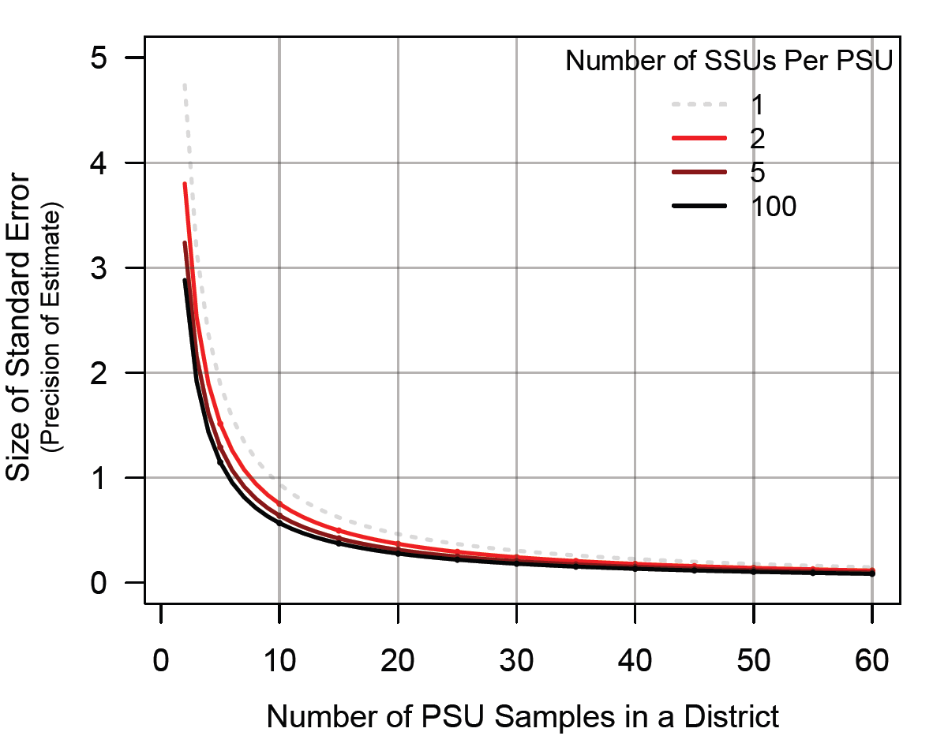
Figure 5. Examining the gain in efficiency for subsampling using Riparian data, in the absence of consideration for costs. Here it is assumed that the variance of the PSU is as observed in the population (5.75), whereas the variance of the subsample was 65% of the PSU (3.75; an estimate of the subsampling variance at the Landscape Unit level).

References
Cochran, W.G. 1977. Sampling techniques. John Wiley & Sons, New York, N.Y.
Hurlbert, S.H. 1984. Pseudoreplication and the Design of Ecological Field Experiments. Ecological Monographs 54(2): 187-211.
Lohr, S.L. 1999. Sampling: design and analysis. Brooks/Cole Publishing Company, Pacific Grove, CA.
Paige, K., L.M. Darling and D. Pickard. 2014. A Guide to Wildlife Resource Value Effectiveness Evaluations. Ecosystems Branch, Ministry of Environment, Resource Practices Br., Ministry of Forests, Lands and Natural Resource Operations. Victoria, BC. FREP Report 37. http://www.for.gov.bc.ca/hfp/frep/publications/index.htm
Pickard, D. and A.W. Hall. 2015. FREP Sampling Design: User Feedback and Preliminary Options for Improvement. Prepared by ESSA Technologies Ltd., Vancouver, B.C. for the Forest and Range Evaluation Program, BC Ministry of Forest, Lands and Natural Resource Operations, Victoria, BC. 42 pp. + Appendices.
Thompson, S.K. 2002. Sampling. 2nd Ed. John Wiley & Sons, New York, N.Y.

APPENDICES

Appendix 1: The FREP Sampling Design
The original monitoring framework was carefully designed. A brief synopsis of some of the key attributes of the sampling design are described below; however, the full details of the sampling design and program scope can be found on the FREP website (https://www.for.gov.bc.ca/hfp/frep/).
The core FREP design uses cutblock-based sampling frame (i.e., cutblocks are the primary sampling unit) and applies simple random selection within each Natural Resource District (i.e., district is the main stratum factor). For the timber value (i.e., stand development monitoring), the main stratum factor is a combination of district and Timber Supply Area (TSA). The random choice of cutblocks within the main stratum factor provides unbiased samples. Given sufficient numbers of cutblocks, outcomes will generally represent the predefined population of harvested cutblocks.
The original architects of the FREP sampling design intentionally decided to select samples based on individual cutblocks and not weight selection by cutblock area. That is, the FREP design uses a simple random selection approach and does not use probability proportional to size. As explained during the January 2015 workshop, the rationale was that FREP is intended to assess the effectiveness of policy and practices on cutblocks, not on area, with an emphasis more on understanding the numbers of successful decisions, rather than estimating attributes across the landscape (e.g., timber volume).
Each FREP value has a slightly different population definition. For most of the values, the population is based upon recent harvest plus key attributes that define the value. Each year, for each district, a population list of all cutblocks harvested in the previous 3 years and greater than 2 ha in gross area is generated from the RESULTS database. This list is randomized (so that moving through the list in sequence represents a simple random selection process). The populations for different FREP values are then refined based on this list, as follows:
- Stand level biodiversity –all blocks
- Riparian – presence of streams in or near blocks
- Water Quality – presence of roads and streams
- Cultural heritage – presence of cultural heritage features
- Visual Quality – visual quality objectives
- Soils – all blocks
- Resource Feature (i.e., pilot for karst) – presence of karst features

The full populations for other FREP values are defined differently. For
- Stand development monitoring (i.e., timber value) – 20-40 year old polygon random list from RESULTS
- Wildlife – wildlife habitat area or ungulate winter range for species of interest (GIS-based) or cutblock (habitat-based)
- Recreation – recreation sites or trails
- Fisheries Sensitive Watershed (FSW) – designated FSW or pending
Ultimately, the FREP program does not have one unifying sampling design across all values, but rather multiple sampling designs for each of the different values, all built upon a common set of fundamental principles and many values sharing a very similar design.
In principle, each district is intended to collect 40 samples per year, but there is no formal guidance on how those should be allocated across values. Consequently, the allocation of sampling effort has been primarily left to the discretion of each district. However, in practice, this goal of 40 samples per year has only been achieved 22% of the time and 43% of the time less than 30 samples have been collected (e.g., over the past 5 years).

Appendix 2: Other Large-scale, Multi-value Monitoring Programs
Broad multi-value, multi-question, multi-region monitoring programs comparable to the scale of FREP are certainly not common. Developing such programs can require a huge investment of time and resources to succeed. The US EPA’s Environmental Monitoring and Assessment Program (EMAP) represents an excellent example of a successful broad-scale (national) and long term monitoring program focused on assessing the status and trends of a range of ecological resources; but doing so required an operating budget averaging around $12M US/year during its 16 year period of implementation. Large investment of funds is common to such regional-scale undertakings but that in itself does not guarantee success. The recent Columbia Basin Collaborative Systemwide Monitoring and Evaluation Project (CSMEP) was supported by over a $1M US/year to bring together biologists from federal and state agencies and First Nations to collaboratively develop and implement broad monitoring and assessment plans for key aquatic resources in the basin. While some useful pilot analyses were developed the project ultimately fell apart only four years into its initial five year funding cycle. Maintaining long term cohesion and focus on key objectives can be problematic within such collaborative, multi-agency programs, and requires a strong unifying theme. The FREP program has, in some regards, the advantage of only involving two agencies (the Ministry of Forests, Lands and Natural Resource Operations (lead) and the Ministry of Environment), though it does require collaboration with each of the districts to implement the monitoring program.
Many successful collaborative monitoring programs, while still ambitious in regard to overall scope (i.e. multi-resource, multi-question, long term), often tend to be more localized in their geographic extent. The Integrated Assessment Program for northern California’s Trinity River Restoration Program (TRRP; http://www.trrp.net/) is an ongoing, successful collaborative monitoring effort led by the US Bureau of Reclamation and supported by a variety of federal, state and Tribal agencies to assess status of aquatic and terrestrial resources affected by the restoration of functional processes within the river basin. Focusing evaluations at the scale of a relatively small river basin has in this case helped maintain consistent effort and results; but even at this geographic scale expenditures are considerable. The annual budget for the TRRP is around $12M US/year, with over $1M US/year spent on the associated monitoring program. By comparison, the FREP program, while covering a much larger geographic scale, operates on a significantly smaller budget.
The realities of trying to capture broad scale, useable but affordable monitoring information for key resources is leading some government agencies to explore novel approaches for data collection. For example the US Forest Service (USFS) is currently putting significant efforts into the monitoring of key aquatic values through crowd-sourcing and citizen science collaborations (Newman et al. 2012) as many important types of data can now be collected inexpensively using standard protocols. Some recent examples of this include USFS monitoring programs to build up and improve broad datasets for stream temperatures and fish species distribution across the entire US Pacific Northwest (see references below). However, even with the cost reductions that may be possible with incorporation of citizen science into such large monitoring programs, there are need still remains for significant and long term agency staff commitments around organizing viable projects, developing protocols, QA/QC of collected data, developing the supporting database infrastructures, outreach materials, etc.
The scale of the FREP monitoring program is not completely unique, but comparable programs are not entirely common either. Such programs are complex, difficult to develop and implement, and expensive to operate. To have developed and implemented a broad, multi-value, multi-question, multi-region monitoring program and maintained it for a decade is a commendable achievement.
References
Newman G. , A. Wiggins, A. Crall, E. Graham, S. Newman, and K. Crowston. 2012. The future of citizen science: emerging technologies and shifting paradigms. Front. Ecol. Environ 2012; 10(6): 298-304. http://monitoringmatters.org/articles/Newman.pdf
US EPA’s Environmental Monitoring and Assessment Program (EMAP):
http://archive.epa.gov/emap/archive-emap/web/html/index.html
USFS examples of using citizen science in monitoring programs:
http://www.fs.fed.us/rm/boise/AWAE/projects/NorWeST.html; http://www.fs.fed.us/rm/boise/AWAE/projects/ClimateShield.html

Appendix 3: Examples of the Allocation of Annual Samples
This appendix shows some examples of using the prospective planning tool to determine the allocation of annual samples in order to meet the minimum requirements for the core sampling design. The tool also indicates the number of surplus samples available for district-specific priorities, assuming a set number of annual samples (i.e., a fixed budget). The figures show how the tool (and thus the approach) works in different situations and demonstrates some of the flexibility in requirements for the allocation of annual samples.
Below is a guide to the components of the figures from the planning tool.
 | The top row shows what district is being used and identifies key parameters. It reminds the user/viewer that the rolling window is 5 years, the minimum samples per value within the rolling window is 30, and the total budget of annual samples is set at 50.
 | The left side of the table shows the existing sampling record, by value and year.
 | The right side of the table is where the prospective sampling plan for future years is entered. The current configuration shows a 10-yr forward-looking planning window.
 | The cumulative performance record evaluates whether the proposed sampling plan will meet the requirements. For each year in the planning window, the number of samples per value within the rolling window are summed. The rolling window is based on that year’s sampling plus the previous four years. Values that are not meeting the minimum are highlighted in red.
 | The bottom two rows provide a summary across values for each future year based on the sampling plan and the requirements. “Min Achieved” gives a pass/fail indicator on whether the minimum requirements will be met across all values in that year. “Priority Samples” indicates how many samples will be available to direct toward district-specific priorities. The number of priority samples available is the difference between the annual total budget and the total allocated to achieving the core design, but only applies if the minimums are met across all values. “TOT” shows the total number of priority samples available over the future planning window.

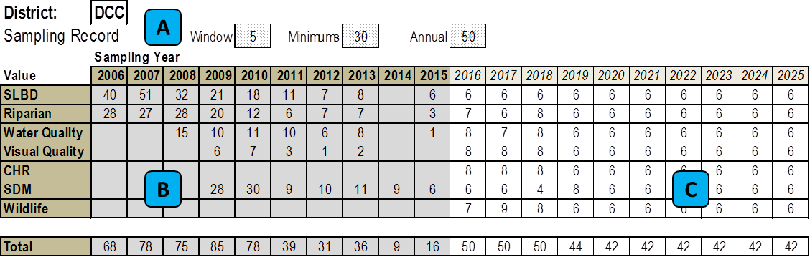
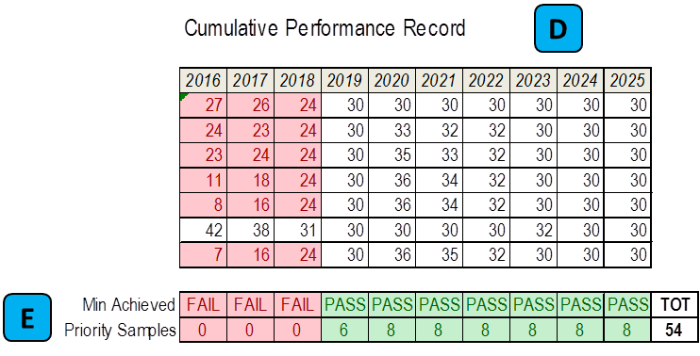

Districts with high versus low recent sampling
Example district with high recent sampling
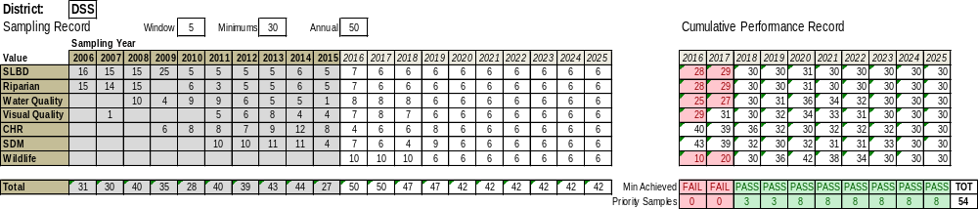
Example district with low recent sampling
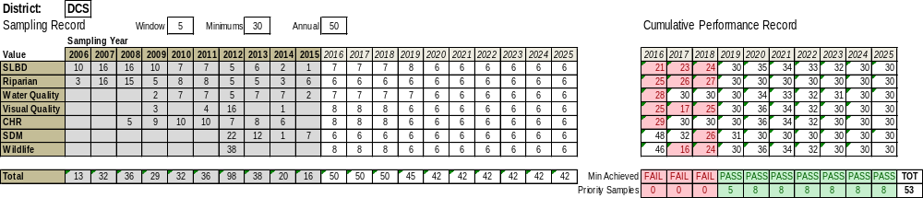

Alternate allocations of sampling effort for a single district
The following examples show alternate ways of allocating the sampling effort for the same district. Some of the pros and cons of each plan are briefly highlighted. This district is required to sample the karst value, so the annual sampling budget is increased to 56 (i.e., to account for the additional 30 samples over 5 years required for an additional value). These are examples of proactive planning in that the plan has been based on looking at the impacts of the plan through time and aiming for achieving a particular pattern. In these examples, a similar pattern is applied to all values, but in practice different patterns could be used for different values.
Evenly distributed effort
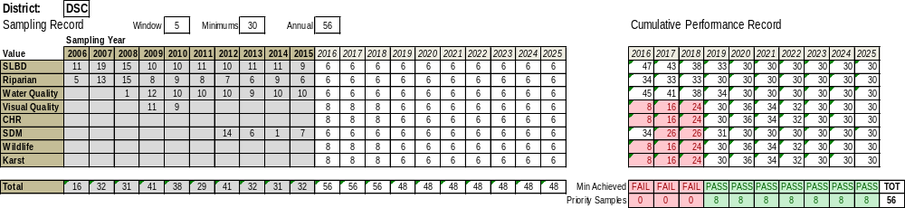
Staggered effort with variable intensity
Each value is sampled 3 out of 5 years with 5, 10, or 15 samples per year. There is the potential for gaining some training efficiency from skipping some years and concentrating more sampling in fewer years. The tradeoff is that the total samples per year is more variable and thus the priority samples available would be less consistent (based on the assumption of a fixed annual budget for the total number of samples).
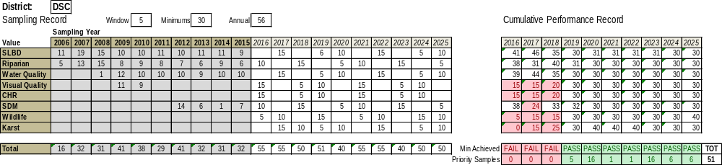
Staggered effort with 10 samples
Each value is sampled 3 out of 5 years, aiming always for 10 samples per year. This pattern is similar to the previous but simpler and with less variability in annual totals (and therefore priority samples available).
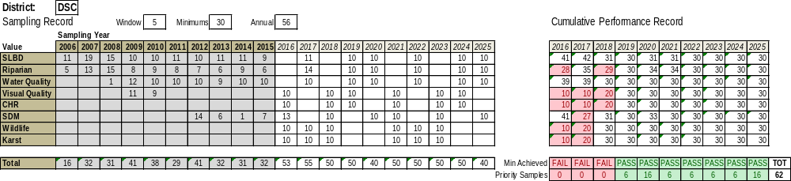
Staggered effort with 15 samples
Each value is sampled 2 out of 5 years, aiming always for 15 samples per year. This pattern focuses the same total effort into fewer years, which could have training benefits for some values. The tradeoffs of this pattern are that the effort occasionally exceeds the annual budget and often exhibits very large differences between years.
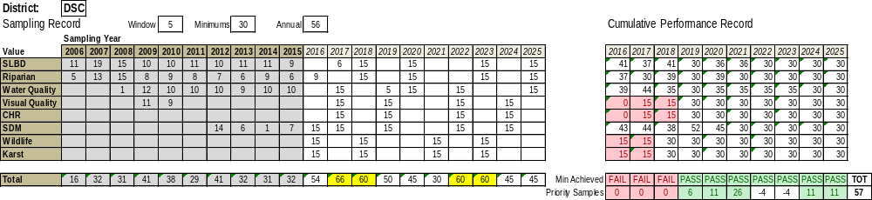

Example of reactive planning for the allocation of samples
In contrast to the “proactive planning” examples above, this example is the result of only ever looking at the current year and never looking further ahead in the planning window. Each year, samples are allocated based the values furthest below their minimums, allowing up to 20 samples per value, and never exceeding the minimums. The outcome is that the plan gets locked into an ad-hoc cycle based on the existing record with no intentional planning with respect to the pattern or frequency. Over time, this approach will result in the greatest number of priority samples, because the minimums are never exceeded, but those samples are highly concentrated in time.
This example uses the same district as the alternate examples of proactively planned allocation shown above.
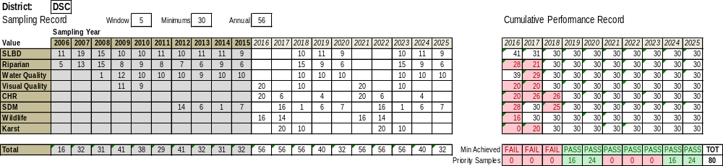

See Appendix 1 for a brief summary of the FREP monitoring program. For further details, refer to https://www.for.gov.bc.ca/hfp/frep/ .
The provincial FREP design is stratified by district. The timber value (i.e., stand development monitoring) is stratified by a combination of district and timber supply area (TSA).
FREP Reports are available at https://www.for.gov.bc.ca/hfp/frep/publications/reports.htm
MRVA Reports are available at https://www.for.gov.bc.ca/hfp/frep/publications/mrva.htm
Additional samples have been collected for the 3 FREP values not included in the subset of “core” values.
Riparian condition is a classification based on the number of NOs: 0-2 = properly functioning; 3-4 = properly functioning, limited impact; 5-6 = properly functioning with impacts; 7+ = not properly functioning.
The sampling fraction is the proportion of sampling units chosen from each district relative to the entire population per district, and is typically small. An adjustment (the finite population correction) is applied get better estimates of precision (i.e., a reduction in the standard error) to account for cases where a substantial fraction of the population was surveyed.
Sample size is calculated by the equation, $n= \frac{{z_{∝/2}}^{2}*p\left(1-p\right)}{L^{2}}$, where $z_{∝/2}$ is the critical value of the normal distribution at α/2 (e.g. for a confidence level of 90%, α=0.1 and the critical value is 1.645), and $L$ is the width of the confidence interval.
The exception is for districts where the current population is less than the required minimums. In these cases, the entire population should be sampled (i.e., a census).
The SDM list is refreshed every five years (i.e., less frequently), therefore setting minimum sampling frequency requirements based on the 3-year restriction will still be acceptable.
The FREP program may specify a definite time period over which alignment with the sampling minimums must be achieved.
The possibility of alternative (potentially nested) sampling frames to address non-cutblock-based activities and outcomes is beyond the scope of the present work.
The sampling frame is the list of sample units from which samples are taken, ideally this list represents the entire population of interest (see FREP Report 37 (Paige et al. 2014) for further definitions of basic sampling design concepts and components).
Considering a sampling frame that is not subset of the existing sampling frame (e.g., unharvested areas), is beyond the scope of the present work. Integrating alternate sampling frames and sampling units within a single monitoring system is statistically complex.
Recall from March 2015 report: “Generally speaking the variance among PSUs is greater than the variance within PSUs and therefore increasing the number of PSUs has a greater impact on precision than increasing the number of SSUs.” (p. 40, see also Figure 3.1).
The interest in being able to address questions and issues at various sub-district scales was a common theme emerging from the survey and workshop. Watershed scale is one example (perhaps the most frequently cited) of a sub-district scale of interest to users.
Landscape Unit was chosen for the example because it is already included as part of the sample data for the riparian value, therefore readily facilitating use as an additional scale for exploring subsampling concepts.

